

**HO CHI MINH CITY UNIVERSITY OF TECHNOLOGY AND EDUCATION**

**FACULTY OF INTERNATIONAL EDUCATION**

**🕯✡🕮🕮✡🕯**

**INTEGRATED CIRCUITS AND SYSTEMS DESIGN**

**ICSD338164E_23_1_01FIE**

Topic: RAM ARBITER

**Members:**

**1. Đỗ Mạnh Dũng 21119301**

**2. Trịnh Lê Minh Hiếu 21119011**

**3. Phạm Trần Minh 21119023**

**4. Đặng Trung Nghĩa 21119313**

**Instructors:**

**Assoc. Prof. Võ Minh Huân**

**Ho Chi Minh City, 12/2023**

**Table of Contents**

**PART A: INTRODUCTION 2**

1.1. Problem Statement: 2

1.2. Problem Resolution: 3

**PART B: MAIN CONTENT 4**

2. RAM 6

2.1. BLOCK DIAGRAM OF RAM 6

2.2. CODING 8

2.3. SCHEMATIC OF RAM 9

2.4. TESTCASES FOR RAM 10

2.5. VERILOG TESTBENCH 10

3. ARBITER 16

3.1. FSM 16

3.2. ARBITER 26

4. RAM ARBITER 42

4.1. PORT MAP IN BETWEEN RAM AND ARBITER 42

4.2. CODING 42

4.3. SCHEMATIC OF RAM ARBITER 44

4.4. TESTCASES FOR RAM ARBITER 44

4.5. VERILOG TESTBENCH 45

4.6. POWER & TIMING 52

**PART C: CONCLUSION 53**

**PART D: REFERENCES 53**

# **PART A: INTRODUCTION**

### 1.1. Problem Statement:

In today's world, with the prevalence of electronic systems and computers, managing memory access becomes a challenge for designers. In an asynchronous environment, where there is no common clock to synchronize events, ensuring efficient and fair memory access becomes a complex issue.

One of the significant challenges arises from concurrently managing multiple memory access requests from different components. When multiple parts of the system simultaneously request access to the memory, deciding which request takes priority becomes crucial. This raises the issue of designing an effective Arbiter, a component that determines which component is allowed memory access and when.

### 1.2. Problem Resolution:

To address these challenges, the project "Designing RAM Arbiter" focuses on researching and developing an intelligent and flexible Arbiter. The Arbiter will ensure that every memory access request is handled fairly, stably, and efficiently.

Through the research process, we will explore methods and algorithms to make informed decisions when multiple requests coincide. The goal is to build an Arbiter with flexible responsiveness, minimizing conflicts and ensuring that every system component has an opportunity for efficient memory access.

This project is not only technically oriented but also an opportunity to contribute to the development of asynchronous systems and memory management. It provides a practical solution to one of the most critical issues in this field.

# **PART B: MAIN CONTENT**

1. TOP LEVEL BLOCK DIAGRAM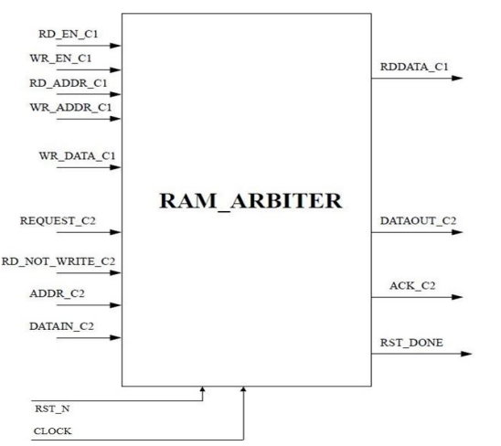

**Top Level View Block Diagram Of Ram_Arbiter**

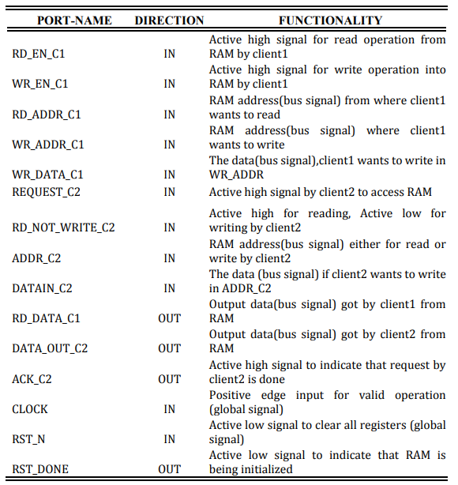

**Port List and their Functionality**

This is the top level block diagram which can interface with two clients (client1 and client2) with their respective input and output ports. But client1 has a higher priority than client2. So client1 can have the access of the RAM any time it wants. But if client2 wants to access the RAM then it must send a request first and according to the following condition Client2 can get the access of the RAM:

1) If client1 is only writing then Client2 can get the access of the RAM for reading only

2) If client1 is only reading then client2 can get the access of the RAM for writing only

3) If client1 is reading and also writing then client2 cannot get any access of the RAM

4) If client1 is not doing anything then Client2 can get the access of the RAM either for reading or writing.

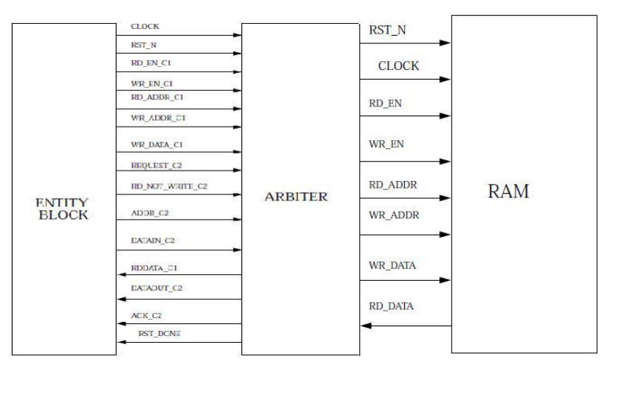

**Internal Architecture of Ram_Arbiter**

## 2. RAM

RAM stands for "Random Access Memory." It is a type of computer memory used to temporarily store data and provide quick access to the processor. Data in RAM can be read and written quickly, and it retains data only as long as the computer is powered on. When the computer is turned off or restarted, the data in RAM is lost.

RAM is primarily used to store programs and data that the processor is currently or will soon be using, and it is designed to provide fast access to this information. In modern applications and operating systems, having a larger RAM capacity often contributes to smoother computer performance and faster processing.

### 2.1. BLOCK DIAGRAM OF RAM

In Random Access Memory (RAM), the memory cells can be accessed for information transfer from any desired random location. That is the process of locating a word in memory is the same and requires an equal amount of time no matter where the cells are located physically in memory: thus the name “Random Access”. Communication between memory and its environment is achieved through data input and output lines, address selection lines, and control lines that specify the direction of transfer. A block diagram of a RAM unit is shown below figure:

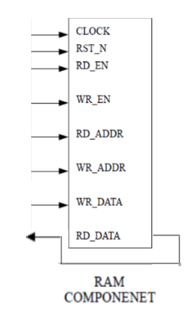

A random-access memory can perform two main operations: write and read. The write signal indicates a transfer-in operation, while the read signal indicates a transfer-out operation. Upon receiving one of these control signals, the internal circuits within the memory execute the desired function. The steps for transferring a new word into memory are as follows:

* Apply the binary address of the desired word to the address lines.
* Input the data bits to be stored in memory into the data input lines.
* Activate the write input.

Subsequently, the memory unit takes the bits currently available in the input data lines and stores them in the word specified by the address lines. The steps for transferring a stored word out of memory are as follows:

* Apply the binary address of the desired word to the address lines.
* Activate the read input.

The memory unit will then take the bits from the word that has been selected by the address and apply them to the output data lines. The content of the selected word does not change after reading.

### 2.2. CODING

**//Declare Module and Parameters.**

**module RAM #(parameter G_ADDR_WIDTH = 4, parameter G_DATA_WIDTH = 8) ; //Declare a Verilog module with the name "RAM."**

**(input CLOCK, RST_N, RD_EN, WR_EN,**

**input [G_ADDR_WIDTH-1:0] RD_ADDR, WR_ADDR,**

**input [G_DATA_WIDTH-1:0] WR_DATA,**

**output reg [G_DATA_WIDTH-1:0] RD_DATA); //Define module parameters (G_ADDR_WIDTH and G_DATA_WIDTH) with default values of 4 and 8.**

**//Declare Constants and Variables.**

**localparam RAM_DEPTH = 2**G_ADDR_WIDTH; // Declare a local constant (RAM_DEPTH) with a value equal to 2 raised to the power of G_ADDR_WIDTH.**

**reg [G_DATA_WIDTH-1:0] MEMORY [0:RAM_DEPTH-1]; // Declare an array named MEMORY as a two-dimensional array of registers with a length of RAM_DEPTH and a width of G_DATA_WIDTH.**

**integer count = 0;**

**reg reset_done;**

**always @(negedge CLOCK) begin**

**// Reset Process**

**if (!RST_N)**

**reset_done <= 1'b1;**

**else begin // If the signal RST_N (inverse of reset) is 0, set reset_done to 1; otherwise, set reset_done to 0.**

**// Initialization Process**

**if ((count < (2**G_ADDR_WIDTH)) && (reset_done == 1'b1)) begin // If count is less than 2^G_ADDR_WIDTH and reset_done is 1,**

**MEMORY[count] <= 0;**

**count <= count + 1; // initialize MEMORY[count] to 0 and increment count by 1.**

**end**

**else begin**

**count <= 0;**

**reset_done <= 1'b0; // Otherwise, set count to 0 and reset_done to 0.**

**end**

**// Main Process (Read and Write)**

**if (!reset_done) begin // Check if the module is not in the reset state (reset_done is 1). If not in the reset state (reset_done is 1), the main process will be executed.**

**// Write Process**

**if (WR_EN) // If WR_EN is 1, indicating a write request, the write process is executed. MEMO // Write data from WR_DATA to the position in memory (MEMORY) corresponding to the address WR_ADDR.**

**if (RD_EN)**

**RD_DATA <= MEMORY[RD_ADDR]; // Assign the value of the memory cell at address RD_ADDR to the output signal RD_DATA.**

**end**

**end**

**end**

**endmodule**

### 2.3. SCHEMATIC OF RAM

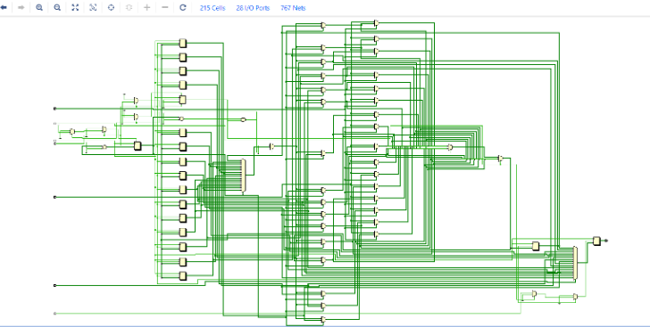

**Schematic of RAM**

### 2.4. TESTCASES FOR RAM

Case 1: RAM write operation

Case 2: RAM read operation

Case 3: RAM read & write operation

### 2.5. VERILOG TESTBENCH

#### 2.5.1. TESTBENCH CODE

**`timescale 1ns / 1ps**

**`timescale 1ns / 1ps**

**module tb_RAM;**

**// Parameters**

**parameter G_ADDR_WIDTH = 4;**

**parameter G_DATA_WIDTH = 8;**

**// Inputs**

**reg CLOCK;**

**reg RST_N;**

**reg RD_EN;**

**reg WR_EN;**

**reg [G_ADDR_WIDTH-1:0] RD_ADDR;**

**reg [G_ADDR_WIDTH-1:0] WR_ADDR;**

**reg [G_DATA_WIDTH-1:0] WR_DATA;**

**// Outputs**

**wire [G_DATA_WIDTH-1:0] RD_DATA;**

**// Instantiate the RAM module**

**RAM #(G_ADDR_WIDTH, G_DATA_WIDTH) uut (**

**.CLOCK(CLOCK),**

**.RST_N(RST_N),**

**.RD_EN(RD_EN),**

**.WR_EN(WR_EN),**

**.RD_ADDR(RD_ADDR),**

**.WR_ADDR(WR_ADDR),**

**.WR_DATA(WR_DATA),**

**.RD_DATA(RD_DATA)**

**);**

**// Clock generation process**

**always #5 CLOCK = ~CLOCK;**

**// Initial stimulus**

**initial begin**

**// Initialize inputs**

**RST_N = 1;**

**CLOCK = 0;**

**RD_EN = 0;**

**WR_EN = 0;**

**RD_ADDR = 0;**

**WR_ADDR = 0;**

**WR_DATA = 0;**

**// Apply reset for a short duration**

**#50 RST_N = 1;**

**// Test Case 1: RAM Write Operation**

**WR_EN = 1;**

**RD_EN = 0;**

**WR_ADDR = 4'b1101;**

**WR_DATA = 8'b11100111;**

**#100;**

**// Test Case 2: RAM Read Operation**

**WR_EN = 0;**

**RD_EN = 1;**

**RD_ADDR = 4'b1101;**

**#100;**

**// Test Case 3: RAM Read & Write Operation**

**WR_EN = 1;**

**RD_EN = 1;**

**RD_ADDR = 4'b1101; //1101 = d is address**

**WR_ADDR = 4'b1011; //1011=b is address**

**WR_DATA = 8'b10111001; // 10111001 = b9 is data**

**#100;**

**// Finish simulation**

**$finish;**

**end**

**endmodule**

**Waveforms:**

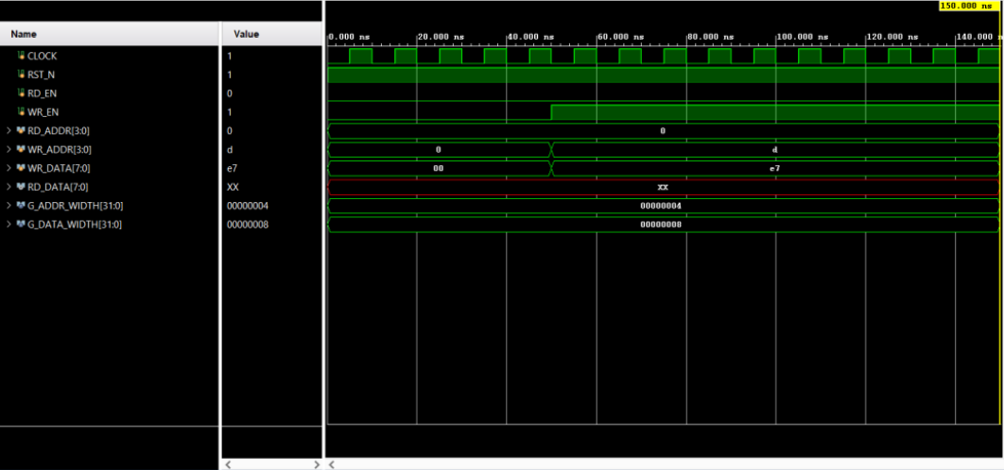

**RAM WRITE OPERATION ( CASE 1 )**

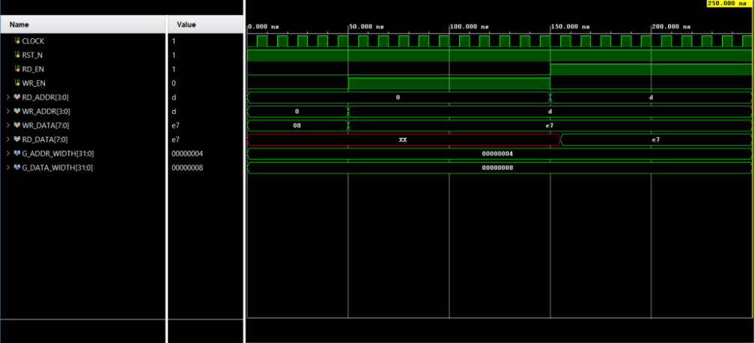

**RAM READ OPERATION ( CASE 2 )**

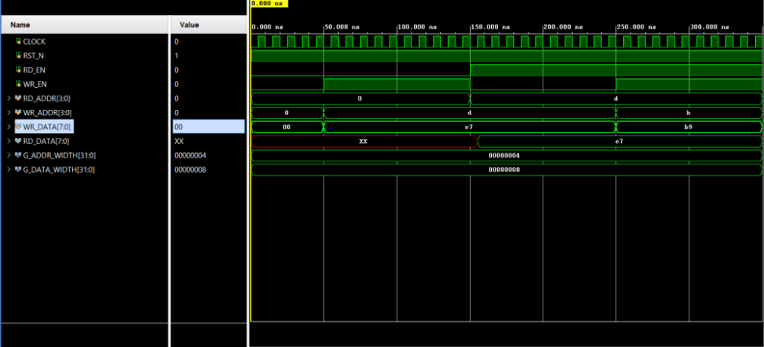

**RAM READ AND WRITE OPERATION ( CASE 3 )**

#### 2.5.2. ANALYSIS OF THE TEST CASE

* **Case 1: Write Operation**

In this case, within the first RAM cycle, it is initialized and the write operation is performed at the address location “1101 ( binary ) = d ( hex )”. The data written is “11100111 = e7 (hex)”. The RAM starts working when the RST_N pin is enabled.

* **Case 2: Read Operation**

Similar to the previous condition, when the RST_N pin is enabled within the first RAM cycle, data is read from the address location “1101 ( binary ) = d ( hex )”.

* **Case 3: Read and Write Operation**

In this instance, a HIGH setting on the reset pin activates the RAM. The data "11100111 (binary ) = e7 ( hex )" is written to the address "1101 ( binary ) = d ( hex)" in the first RAM cycle. We aim to demonstrate that the RAM design could handle both read and write operations in a single RAM cycle in the second RAM cycle. While data "10111001 ( binary ) = b9 (hex)” was being written at the address location "1011 ( binary ) = b ( hex )," data was being read from location "1101".

#### 2.5.3. POWER & TIMING

**Power:**

* Dynamic Power: It is the energy consumed during the transition of states from 0 to 1 or vice versa. This occurs when flip-flops change states or when transistors switch states during computation.
* 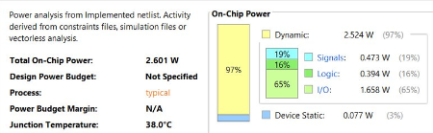Static Power: It is the energy consumed even when the circuit is not active (no dynamic transitions). The main cause is due to the leakage current of transistors and other energy loss.



**Setup Time and Hold Time:**

* Setup time is the time before a synchronous signal changes that the input data needs to be stable.
* Hold time is the time after a synchronous signal changes that the input data needs to be held stable.

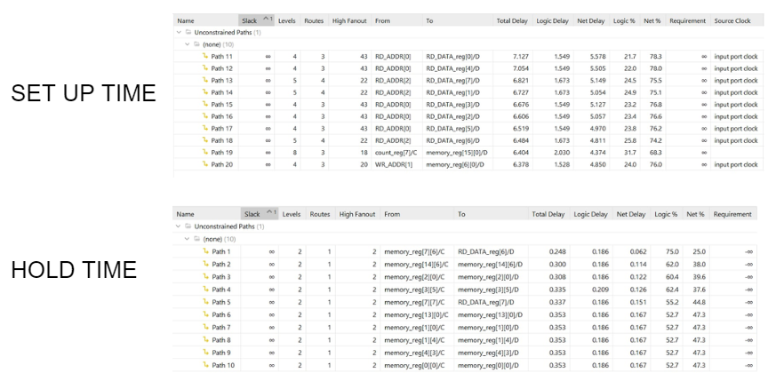

## 3. ARBITER

### 3.1. FSM

#### 3.1.1. BLOCK DIAGRAM

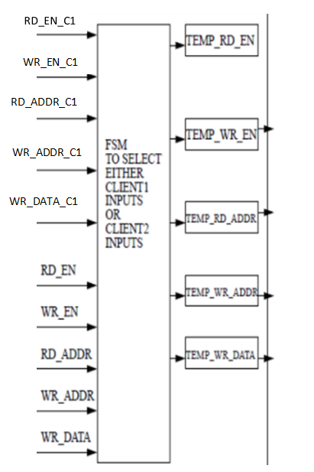

#### 3.1.2. FSM DESIGN BLOCK

This FSM determines which client gets access to the specified RAM depending on the following conditions:

1) If Client1 is writing into RAM but not reading, then Client2 can read but can’t write.

2) If Client1 is reading from RAM but not writing, then Client2 can write but can’t read.

3) If Client2 is reading and Client1 wants to read then Client1 gets access to RAM.

4) If Client2 is writing and Client1 wants to write then Client1 gets access to RAM.

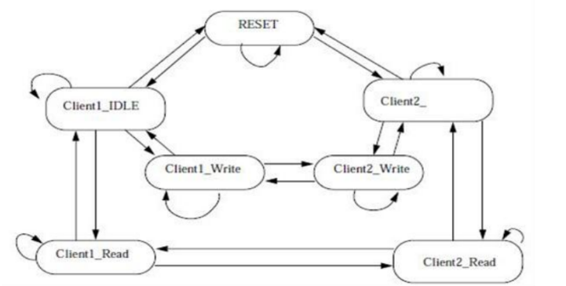

On applying RST_N=0 FSM will be in RESET state and after RST_N=1 it will take RAM_DEPTH cycles to reach in IDLE state and any input can be accepted after reaching IDLE state.

Transition of states depending upon different input conditions from the clients are given

below:

1. IDLE----->Client1_Read==> RD_EN_C1=1.

2. Client1_Read----->IDLE==> RD_EN_C1=0.

3. IDLE---->Client1_Write==> WR_EN_C1=1.

4. Client1_Write---->IDLE==> WR_EN_C1=0.

5. IDLE--->Client2_Read==> RD_EN_C1=0 and REQUEST_C2=1 and D_NOT_WRITE_C2=1.

6. Client2_Read--->IDLE==>REQUEST_C2=0 or REQUEST_C2=1 and D_NOT_WRITE_C2=0.

7. IDLE--->Client2_Write==>WR_EN_C1=0 and REQUEST_C2=1 and D_NOT_WRITE_C2=0.

8. Client2_Write-->IDLE==>REQUEST_C2=0 or REQUEST_C2=1 and

RD_NOT_WRITE_C2=1.

9. Client2_Read---->Client1_Read===>RD_EN_C1=1.

10. Client1_Read----->Client2_Read===>RD_EN_C1=0 and REQUEST_C2=1 and

RD_NOT_WRITE_C2=1.

11. Client2_Write----->Client1_Write==>WR_EN_C1=1.

12. Client1_Write----->Client2_Write==>WR_EN_C1=0 and REQUEST_C2=1 and

RD_NOT_WRITE_C2=0.

13. Client1_Read--->Client1_Read==>RD_EN_C1=1.

14. Client1_Write--->Client1_Write==>WR_EN_C1=1.

15. Client2_Read--->Client2_Read===>REQUEST_C2=1 and RD_NOT_WRITE_C2=1 and RD_EN_C1=0.

16. Client2_Write---->Client2_Write===>REQUEST_C2=1 and RD_NOT_WRITE_C2=0 and WR_EN_C1=0.

17. IDLE---->IDLE===>RD_EN_C1=0 and WR_EN_C1=0 and REQUEST_C2=0.

18. RESET--->RESET===>if RST_N=0 holds or RST_N=0 for once and RST_DONE=0

19. RESET--->IDLE===>RST_N=1 and RST_DONE=1.

20. IDLE--->RESET==>RST_N=0.

#### 3.1.3. CODING

module FSM #(

parameter G_ADDR_WIDTH = 4,

parameter G_DATA_WIDTH = 8,

parameter G_REGISTERED_DATA = 0)

(

input RST_N, CLOCK,

output RST_DONE,

input RD_EN_C1, WR_EN_C1, // Read enable, write enable

input [G_ADDR_WIDTH-1 : 0] RDADDR_C1, WRADDR_C1, // Read address, write address

input [G_DATA_WIDTH-1 : 0] WRDATA_C1,

input [G_DATA_WIDTH-1 : 0] DATAIN_C2,

input REQUEST_C2, RD_NOT_WRITE_C2, // Request for memory access and read-write bar

input [G_ADDR_WIDTH-1 : 0] ADDR_C2, // This address is for both read and write one at a time

output [G_DATA_WIDTH-1 : 0] RDDATA_C1, // Data out for client1/user1

output [G_DATA_WIDTH-1 : 0] DATAOUT_C2, // Data out for client2/user2

output ACK_C2, // Acknowledgement in the case of client2,

// since it will not be given access immediately

// since priority is more of client1

output RD_EN, WR_EN, // Read and write enable signals for the arbiter

output [G_ADDR_WIDTH-1 : 0] WR_ADDR, RD_ADDR, // Write and read address signals

output [G_DATA_WIDTH-1 : 0] WR_DATA, // Write data signal

input [G_DATA_WIDTH-1 : 0] RD_DATA // Read data signal

);

/// Temporary registers to store data during state transitions

reg [G_DATA_WIDTH-1 : 0] TEMP_RD_DATA, TEMP_RD_DATA1, TEMP_RD_DATA2;

reg TEMP_RD_EN, TEMP_WR_EN;

reg [G_ADDR_WIDTH-1 : 0] TEMP_WR_ADDR, TEMP_RD_ADDR;

reg [G_DATA_WIDTH-1 : 0] TEMP_WR_DATA;

// Enumerated values for FSM states

localparam [2:0] reset=3'b000, idle=3'b001, client1_read=3'b010, client2_read=3'b011, client1_write=3'b100, client2_write=3'b101;

// Registers to store current and next states for clients

reg [2:0] pr_client_read, pr_client_write, nx_client_read, nx_client_write;

// Acknowledgment signals for clients

reg TEMP_ACK = 0, TEMP_ACK1, TEMP_ACK2, TEMP_WR=0;

wire TEMP_WR1;

// Signal for registered data

wire REGISTERED_DATA = 0;

reg RESET_DONE_REG;

// Counter for reset completion

integer COUNT = 0;

// Signals for address clash detection

reg ADDR_CLASHI=0, ADDR_CLASH=0;

// FSM

always @(posedge CLOCK, negedge RST_N) begin

if (!RST_N) begin

// Initialization during reset

pr_client_read <= reset; //+ Initialize the client read state during the reset state

pr_client_write <= reset; //+ Initialize the client write state during the reset state

end

else begin

// Update current states

pr_client_read <= nx_client_read; //+ Update the client read state

pr_client_write <= nx_client_write; //+ Update the client write state

end

end

// Generate block for handling registered data

generate

if (G_REGISTERED_DATA) begin : g1

assign REGISTERED_DATA = G_REGISTERED_DATA; //+ Assign the value of the REGISTERED_DATA parameter

end

endgenerate

// FSM state transition logic

always @(pr_client_read, pr_client_write, CLOCK) begin

if (RST_N & CLOCK) begin

// Reset state initialization

if (nx_client_read==reset && nx_client_write==reset) begin

if (COUNT < (2**G_ADDR_WIDTH)) begin

// Reset not done yet

RESET_DONE_REG <= 1'b0;

COUNT <= COUNT + 1;

end

else begin

// Reset done

nx_client_read = idle;

nx_client_write = idle;

RESET_DONE_REG = 1'b1;

COUNT = 0;

end

end

end

else if(!RST_N) begin

// Reset condition

nx_client_read = reset;

nx_client_write = reset;

end

// State transitions based on current state

// Handling idle state

if (pr_client_read == idle) begin

if (!RD_EN_C1) begin

if (!REQUEST_C2)

nx_client_read = idle; //+ In idle state and no read requests from client 1 or 2, stay in idle state

else if (RD_NOT_WRITE_C2)

nx_client_read = client2_read; //+ If there is a request from client 2 and it's a read request, transition to client 2 read state

else if (!RD_NOT_WRITE_C2)

nx_client_write = client2_write; //+ If there is a request from client 2 and it's a write request, transition to client 2 write state

end

else

nx_client_read = client1_read; //+ If there is a read request from client 1, transition to client 1 read state

end

if (pr_client_write == idle) begin

if (!WR_EN_C1) begin

if (!REQUEST_C2)

nx_client_write = idle; //+ In idle state and no write requests from client 1 or 2, stay in idle state

else if (!RD_NOT_WRITE_C2)

nx_client_write = client2_write; //+ If there is a request from client 2 and it's a write request, transition to client 2 write state

else if (RD_NOT_WRITE_C2)

nx_client_read = client2_read; //+ If there is a request from client 2 and it's a read request, transition to client 2 read state

end

else

nx_client_write = client1_write; //+ If there is a write request from client 1, transition to client 1 write state

end

// Handling client1 read state

if (pr_client_read == client1_read) begin

if (RD_EN_C1)

nx_client_read = client1_read; //+ In client 1 read state and there is a read request from client 1, stay in client 1 read state

else begin

if (!REQUEST_C2)

nx_client_read = idle; //+ In client 1 read state and no requests from client 2, transition to idle state

else if (RD_NOT_WRITE_C2)

nx_client_read = client2_read; //+ In client 1 read state and there is a read request from client 2, transition to client 2 read state

else if (!RD_NOT_WRITE_C2)

nx_client_read = idle; //+ In client 1 read state and there is a write request from client 2, transition to idle state

end

end

// Handling client1 write state

if (pr_client_write == client1_write) begin

if (WR_EN_C1)

nx_client_write = client1_write; //+ In client 1 write state and there is a write request from client 1, stay in client 1 write state

else begin

if (!REQUEST_C2)

nx_client_write = idle; //+ In client 1 write state and no requests from client 2, transition to idle state

else if (!RD_NOT_WRITE_C2)

nx_client_write = client2_write; //+ In client 1 write state and there is a write request from client 2, transition to client 2 write state

else if (RD_NOT_WRITE_C2)

nx_client_write = idle; //+ In client 1 write state and there is a read request from client 2, transition to idle state

end

end

// Handling client2 read state

if (pr_client_read == client2_read) begin

if (!RD_EN_C1) begin

if (REQUEST_C2) begin

if (RD_NOT_WRITE_C2)

nx_client_read = client2_read; //+ In client 2 read state and there is a read request from client 2, stay in client 2 read state

else begin

nx_client_read = idle; //+ In client 2 read state and there is a write request from client 2, transition to idle state

nx_client_write = client2_write; //+ In client 2 read state and there is a write request from client 2, transition to client 2 write state

end

end

else

nx_client_read = idle; //+ In client 2 read state and no requests from client 2, transition to idle state

end

else

nx_client_read = client1_read; //+ In client 2 read state and there is a read request from client 1, transition to client 1 read state

end

// Handling client2 write state

if (pr_client_write == client2_write) begin

if (!WR_EN_C1) begin

if (REQUEST_C2) begin

if (!RD_NOT_WRITE_C2)

nx_client_write = client2_write; //+ In client 2 write state and there is a write request from client 2, stay in client 2 write state

else begin

nx_client_write = idle; //+ In client 2 write state and there is a read request from client 2, transition to idle state

nx_client_read = client2_read; //+ In client 2 write state and there is a read request from client 2, transition to client 2 read state

end

end

else

nx_client_write = idle; //+ In client 2 write state and no requests from client 2, transition to idle state

end

else

nx_client_write = client1_write; //+ In client 2 write state and there is a write request from client 1, transition to client 1 write state

end

end

endmodule

#### 3.1.4. SCHEMATIC

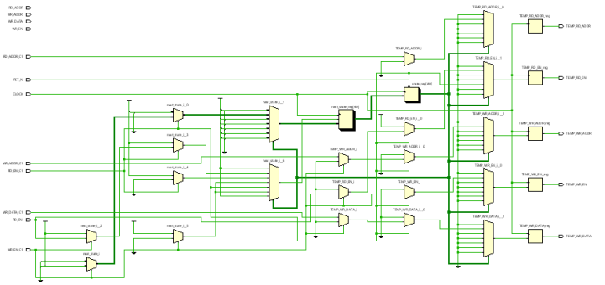

**Schematic of FSM**

### 3.2. ARBITER

#### 3.2.1. BLOCK DIAGRAM

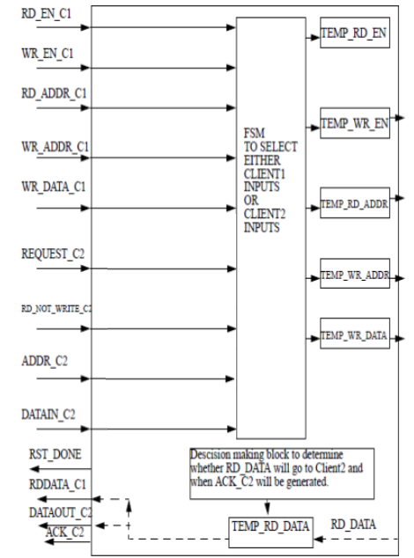

**Block Diagram Of Arbiter**

#### 3.2.2. CODING

module arbiter #(

parameter G_ADDR_WIDTH = 4,

parameter G_DATA_WIDTH = 8,

parameter G_REGISTERED_DATA = 0)

(

input RST_N, CLOCK,

output RST_DONE,

input RD_EN_C1, WR_EN_C1, // Read enable, write enable

input [G_ADDR_WIDTH-1 : 0] RDADDR_C1, WRADDR_C1, // Read address, write address

input [G_DATA_WIDTH-1 : 0] WRDATA_C1,

input [G_DATA_WIDTH-1 : 0] DATAIN_C2,

input REQUEST_C2, RD_NOT_WRITE_C2, // Request for memory access and read-write_bar

input [G_ADDR_WIDTH-1 : 0] ADDR_C2, // This address is for both read and write one at a time

output [G_DATA_WIDTH-1 : 0] RDDATA_C1, // Data out for client1/user1

output [G_DATA_WIDTH-1 : 0] DATAOUT_C2, // Data out for client2/user2

output ACK_C2, // Acknowledgement in case of client2, since it will not be given access immediately since priority is more of client1

output RD_EN, WR_EN,

output [G_ADDR_WIDTH-1 : 0] WR_ADDR, RD_ADDR,

output [G_DATA_WIDTH-1 : 0] WR_DATA,

input [G_DATA_WIDTH-1 : 0] RD_DATA

);

// Registers to hold temporary data

reg [G_DATA_WIDTH-1 : 0] TEMP_RD_DATA, TEMP_RD_DATA1, TEMP_RD_DATA2;

reg TEMP_RD_EN, TEMP_WR_EN;

reg [G_ADDR_WIDTH-1 : 0] TEMP_WR_ADDR, TEMP_RD_ADDR;

reg [G_DATA_WIDTH-1 : 0] TEMP_WR_DATA;

// FSM states

localparam [2:0] reset = 3'b000, idle = 3'b001, client1_read = 3'b010, client2_read = 3'b011, client1_write = 3'b100, client2_write = 3'b101;

// FSM state registers

reg [2:0] pr_client_read, pr_client_write, nx_client_read, nx_client_write;

// Acknowledgement registers

reg TEMP_ACK = 0, TEMP_ACK1, TEMP_ACK2, TEMP_WR=0;

wire TEMP_WR1;

// Wire to determine if data should be registered

wire REGISTERED_DATA = 0;

// Reset-related variables

reg RESET_DONE_REG;

integer COUNT = 0;

// Address clash detection signals

reg ADDR_CLASHI=0, ADDR_CLASH=0;

// FSM

always @(posedge CLOCK, negedge RST_N) begin

if (!RST_N) begin

pr_client_read <= reset;

pr_client_write <= reset;

end

else begin

pr_client_read <= nx_client_read;

pr_client_write <= nx_client_write;

end

end

// Conditional assignment of REGISTERED_DATA based on the parameter G_REGISTERED_DATA

generate

if (G_REGISTERED_DATA) begin : g1

assign REGISTERED_DATA = G_REGISTERED_DATA;

end

endgenerate

// FSM logic

always @(pr_client_read, pr_client_write, CLOCK) begin

if (RST_N & CLOCK) begin

// Reset logic

if (nx_client_read == reset && nx_client_write == reset) begin

if (COUNT < (2**G_ADDR_WIDTH)) begin

RESET_DONE_REG <= 1'b0;

COUNT <= COUNT + 1;

end

else begin

nx_client_read = idle;

nx_client_write = idle;

RESET_DONE_REG = 1'b1;

COUNT = 0;

end

end

end

else if(!RST_N) begin

nx_client_read = reset;

nx_client_write = reset;

end

// FSM state transitions

// ... (state transition logic)

end

// Register data assignment logic

always @(posedge CLOCK) begin

if (!RST_N) begin

TEMP_RD_DATA <= 0;

TEMP_RD_DATA1 <= 0;

TEMP_RD_DATA2 = 0;

end

else begin

// Read data assignment

if (nx_client_read == idle) begin

TEMP_RD_EN <= 1'b0;

TEMP_RD_ADDR <= 0;

end

else if (nx_client_read == client1_read) begin

TEMP_RD_EN <= RD_EN_C1;

TEMP_RD_ADDR <= RDADDR_C1;

end

else if (nx_client_read == client2_read) begin

if (!TEMP_ACK) begin

TEMP_RD_EN <= 1'b1;

TEMP_RD_ADDR <= ADDR_C2;

TEMP_ACK <= 1'b1;

end

end

// Write data assignment

if (nx_client_write == idle) begin

TEMP_WR_EN <= 1'b0;

TEMP_WR_DATA <= 0;

TEMP_WR_ADDR <= 0;

end

else if (nx_client_write == client1_write) begin

TEMP_WR_EN <= WR_EN_C1;

TEMP_WR_DATA <= WRDATA_C1;

TEMP_WR_ADDR <= WRADDR_C1;

end

else if (nx_client_write == client2_write) begin

if (!TEMP_WR) begin

TEMP_WR_EN <= 1'b1;

TEMP_WR_ADDR <= ADDR_C2;

TEMP_WR_DATA <= DATAIN_C2;

TEMP_WR <= 1'b1;

end

end

// Additional logic

ADDR_CLASHI <= ADDR_CLASH;

TEMP_RD_DATA1 <= TEMP_RD_DATA;

TEMP_RD_DATA2 <= RD_DATA;

end

end

// Output assignments

assign RD_EN = TEMP_RD_EN;

assign WR_EN = TEMP_WR_EN;

assign WR_DATA = TEMP_WR_DATA;

assign WR_ADDR = TEMP_WR_ADDR;

assign RD_ADDR = TEMP_RD_ADDR;

assign TEMP_WR1 = TEMP_WR;

assign ACK_C2 = (TEMP_ACK1 | TEMP_WR1) ? 1'b1 : 1'b0;

assign RST_DONE = RESET_DONE_REG;

assign DATAOUT_C2 = (!ADDR_CLASH) ? RD_DATA : TEMP_RD_DATA;

assign RDDATA_C1 = (REGISTERED_DATA == 0 && ADDR_CLASH == 1'b0 ) ? RD_DATA :

(REGISTERED_DATA == 0 && ADDR_CLASH == 1'b1 ) ? TEMP_RD_DATA :

(REGISTERED_DATA == 1 && ADDR_CLASHI == 1'b0 ) ? TEMP_RD_DATA2 :

(REGISTERED_DATA == 1 && ADDR_CLASHI == 1'b1 ) ? TEMP_RD_DATA1 : RDDATA_C1;

End

#### 3.2.3. SCHEMATIC

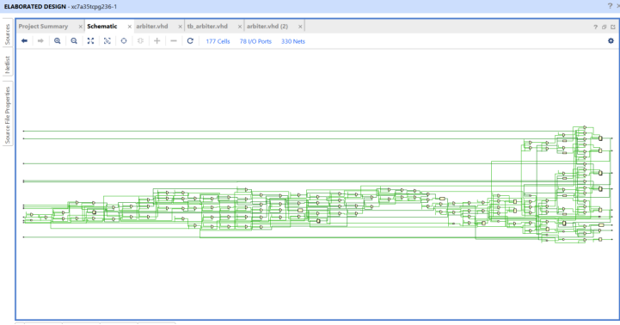

Arbiter’s schematic

#### 3.2.4. TESTCASES

Case 1 : Only Client1 wants to write.

Case 2 : Only Client1 wants to read.

Case 3 : Only Client2 wants to write.

Case 4: Only Client2 wants to read.

#### 3.2.5. VERILOG TESTBENCH

##### 3.2.5.1.TESTBENCH CODE

module arbiter;

// Component Declaration for the Unit Under Test (UUT)

ARBITER_NEW uut (

.RST_N(RST_N), // Reset input to the UUT

.CLOCK(CLOCK), // Clock input to the UUT

.RST_DONE(RST_DONE), // Output signal indicating reset is done

.RD_EN_C1(RD_EN_C1), // Read enable for client1

.WR_EN_C1(WR_EN_C1), // Write enable for client1

.RDADDR_C1(RDADDR_C1), // Read address for client1

.WRADDR_C1(WRADDR_C1), // Write address for client1

.WRDATA_C1(WRDATA_C1), // Write data for client1

.DATAIN_C2(DATAIN_C2), // Data input for client2

.REQUEST_C2(REQUEST_C2), // Request signal for client2

.RD_NOT_WRITE_C2(RD_NOT_WRITE_C2), // Read not write signal for client2

.ADDR_C2(ADDR_C2), // Address signal for client2

.RDDATA_C1(RDDATA_C1), // Read data for client1

.DATAOUT_C2(DATAOUT_C2), // Data output for client2

.ACK_C2(ACK_C2), // Acknowledge signal for client2

.RD_EN(RD_EN), // Read enable signal

.WR_EN(WR_EN), // Write enable signal

.WR_ADDR(WR_ADDR), // Write address signal

.RD_ADDR(RD_ADDR), // Read address signal

.WR_DATA(WR_DATA), // Write data signal

.RD_DATA(RD_DATA) // Read data signal

);

// Inputs

reg RST_N = 0; // Reset signal (active low)

reg CLOCK = 0; // Clock signal

reg RD_EN_C1 = 0; // Read enable for client1

reg WR_EN_C1 = 0; // Write enable for client1

reg [3:0] RDADDR_C1 = 4'b0000; // Read address for client1

reg [3:0] WRADDR_C1 = 4'b0000; // Write address for client1

reg [7:0] WRDATA_C1 = 8'b00000000; // Write data for client1

reg [7:0] DATAIN_C2 = 8'b00000000; // Data input for client2

reg REQUEST_C2 = 0; // Request signal for client2

reg RD_NOT_WRITE_C2 = 0; // Read not write signal for client2

reg [3:0] ADDR_C2 = 4'b0000; // Address signal for client2

reg [7:0] RD_DATA = 8'b00000000; // Read data for client1

// Outputs

wire RST_DONE; // Output signal indicating reset is done

wire [7:0] RDDATA_C1; // Read data for client1

wire [7:0] DATAOUT_C2; // Data output for client2

wire ACK_C2; // Acknowledge signal for client2

wire RD_EN; // Read enable signal

wire WR_EN; // Write enable signal

wire [3:0] WR_ADDR; // Write address signal

wire [3:0] RD_ADDR; // Read address signal

wire [7:0] WR_DATA; // Write data signal

// Clock period definitions

parameter CLOCK_period = 100; // Clock period set to 100 time units

// Clock process definitions

always #CLOCK_period/2 CLOCK = ~CLOCK; // Clock toggles every half the specified period

// Stimulus process

initial begin

// Test case

// Hold reset state for 100 ns.

#100;

// Add more test cases here…

#Case 1: Only Client1 wants to write

RST_N <= 1;

#500;

WR_EN_C1 <= 1;

WRADDR_C1 <= 4'b1010; WRDATA_C1 <= 8'b10100011;

#Case 2: Only Client1 wants to read

RST_N <= 1; #500;

WR_EN_C1 <= 1;

WRADDR_C1 <= 4'b1010;

WRDATA_C1 <= 8'b10100011;

#1700;

WR_EN_C1 <= 0;

RD_EN_C1 <= 1;

RDADDR_C1 <= 4'b1010;

#Case 3: Only Client2 wants to write

RST_N <= 1;

WR_EN_C1 <= 0;

REQUEST_C2 <= 1;

RD_NOT_WRITE_C2 <= 0;

ADDR_C2 <= 4'b1110;

DATAIN_C2 <= 8'b11100011;

#Case 4: Only Client2 wants to read

RST_N <= 1;

WR_EN_C1 <= 0;

REQUEST_C2 <= 1; RD_NOT_WRITE_C2 <= 0;

ADDR_C2 <= 4'b1110;

DATAIN_C2 <= 8'b11100011; #1700; WR_EN_C1 <= 0; RD_NOT_WRITE_C2 <= 1;

ADDR_C2 <= 4'b1110;

// End simulation after running test cases

$stop;

end

endmodule

**WAVEFORMS**

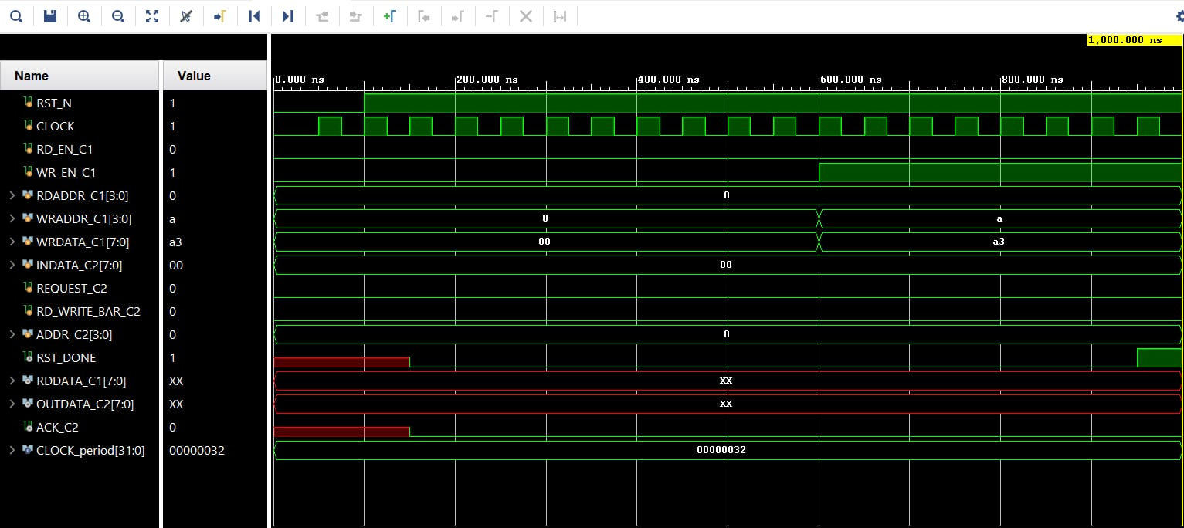

**Case 1: Only Client1 wants to write**

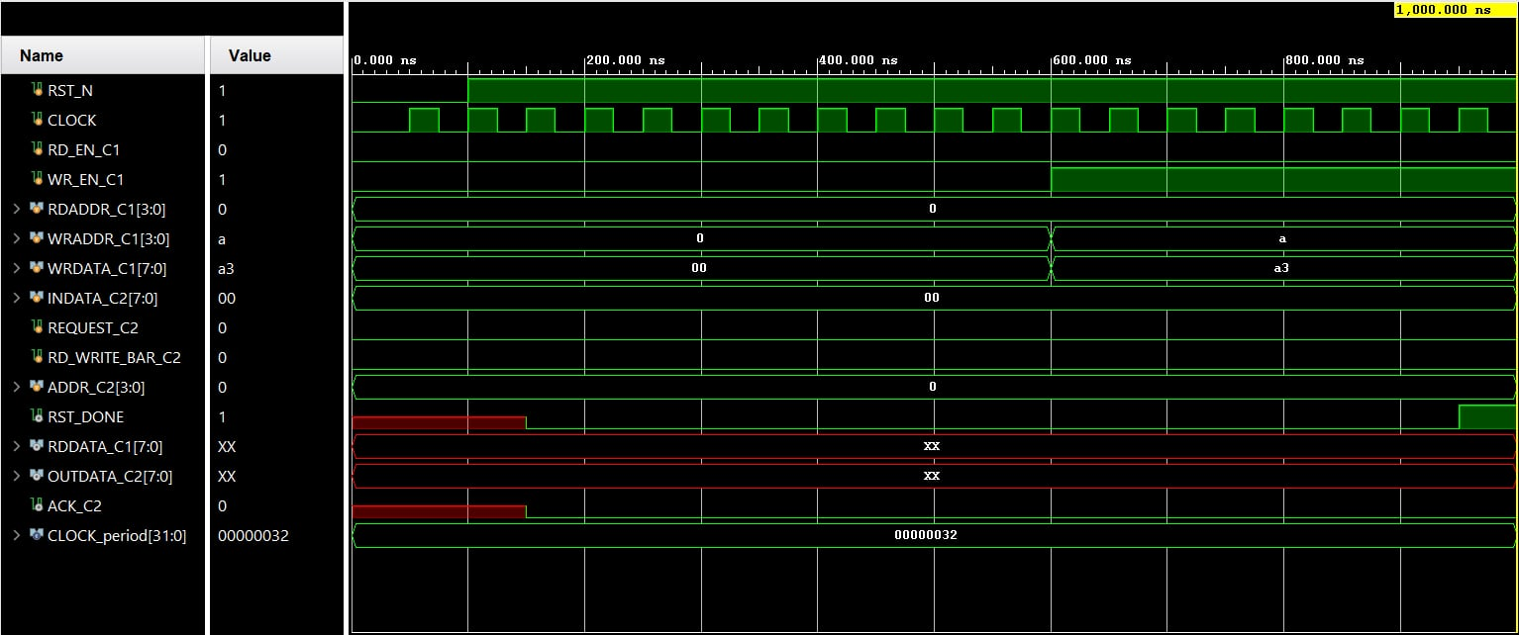

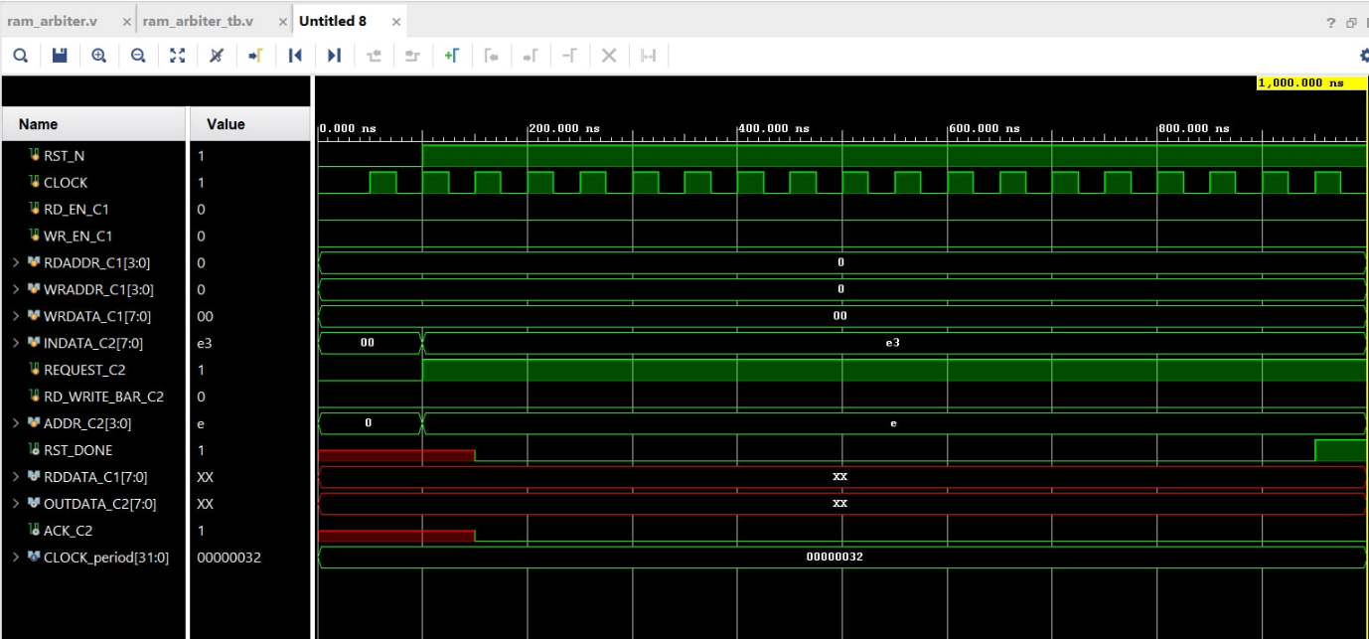**Case 2: Only Client1 wants to read (Fail simulation)**

**Case 3: Only Client2 wants to write**

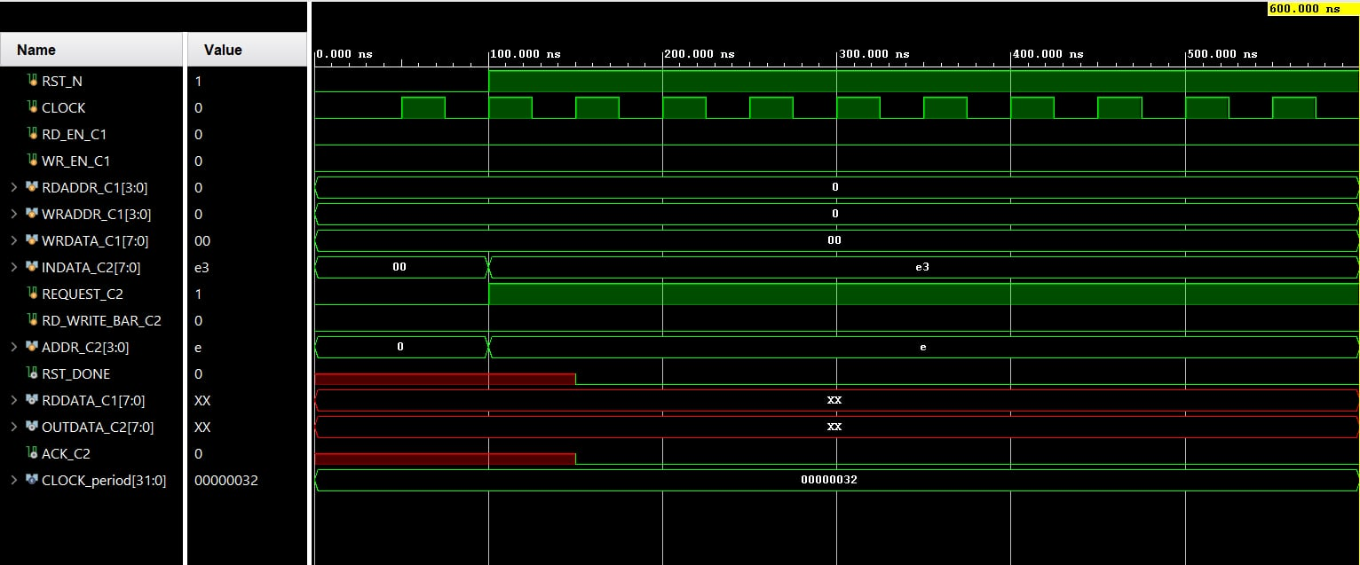

**Case 4: Only Client2 wants to read (Fail simulation)**

##### 3.2.5.2. ANALYSIS OF THE TESTCASES

**Case1: Only Client1 wants to write.**

In this case, when the RST_N pin is enabled, the arbiter starts its operation. Within the first RAM_DEPTH cycle, Client1 enables its WR_EN_C1 pin and writes the data “ a3 ” at the address location “ a ”. The arbiter places the data it received, on the input pins of the RAM i.e. the WR_ADDR receives the address location and the WR_DATA receives the data.

**Case 2: Only Client1 wants to read.**

The Arbiter starts working as soon as the RST_N pin is enabled. The clock period is set to 50ns. Within the first RAM_DEPTH cycle, a data “ a3 ” is written at the location “ a ”. The R_EN_C1 pin is enabled to facilitate the operation. During the next RAM_DEPTH cycle, Client1 wishes to read at the RAM location “ a ” by enabling the RD_EN_C1 pin.

**Case3: Only Client2 wants to write.**

Here in this case, the Arbiter starts working as soon as the RST_N pin is set high. The clock period is set to 50 ns. As the arbitration scheme used is a priority based one, so Client2 needs to issue a signal on the REQUEST_C2 pin in order to access the RAM. Here the priority is given to Client1.Within the first RAM_DEPTH cycle, REQUEST_C2 pin is enabled to allow Client2 to access the RAM. Client2 uses two states of a single pin RD_NOT_WRITE to perform both of its read and write operation. This pin only works if REQUEST_C2 pin is enabled. Upon enabling REQUEST_C2, RD_NOT_WRITE is set to low to allow for the write operation. Data “ e3 ” is written at the location “ e ”. The arbiter acknowledges the write operation by setting up periodic pulses at the ACK_C2 output pin.

**Case 4: Only Client2 wants to read.**

In this case, within the first RAM_DEPTH cycle, data “ e3 ” is written in the address location “ e ” by enabling the REQUEST_C2 pin and setting RD_NOT_WRITE pin to an active low state. However in the second RAM_DEPTH cycle, Client2 activates the high signal on RD_NOT_WRITE pin and issue a signal to the arbiter to read from location “ e ”. The read operation is acknowledged by the Arbiter by issuing clock pulses at the ACK_C2 pin whose clock period is two times that of the former one.

#### 3.2.6. FPGA

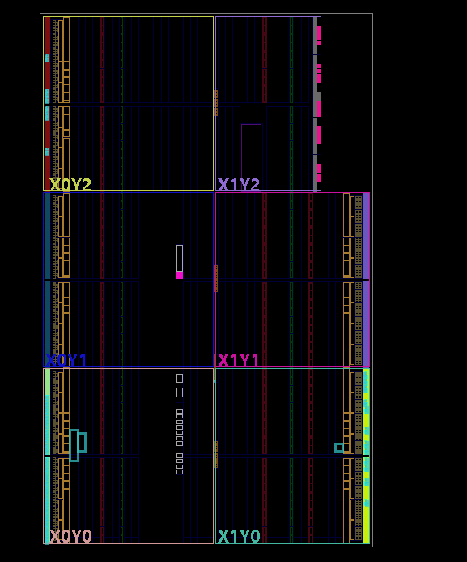

#### 3.2.7. Power & Timing

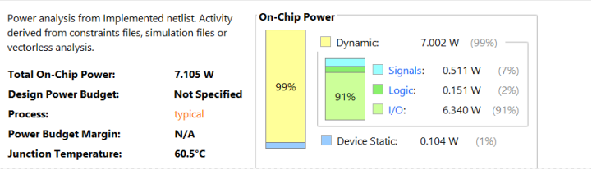

**POWER**

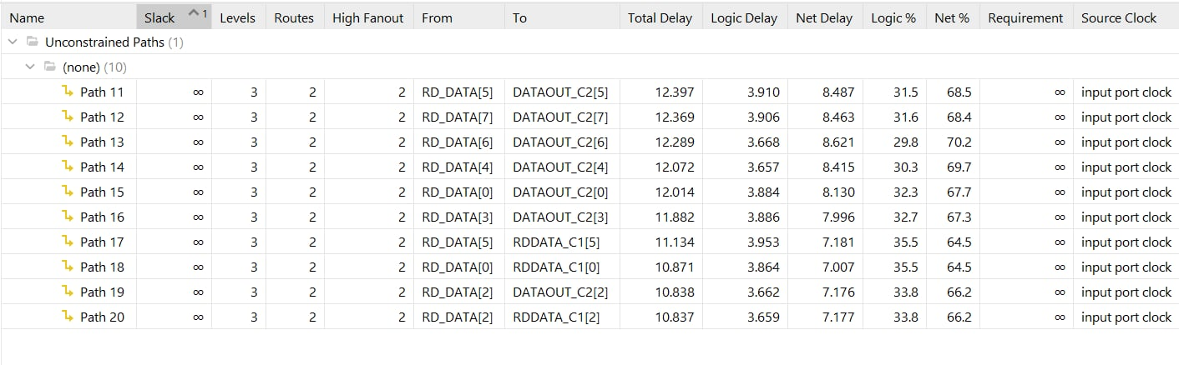

SET UP TIME

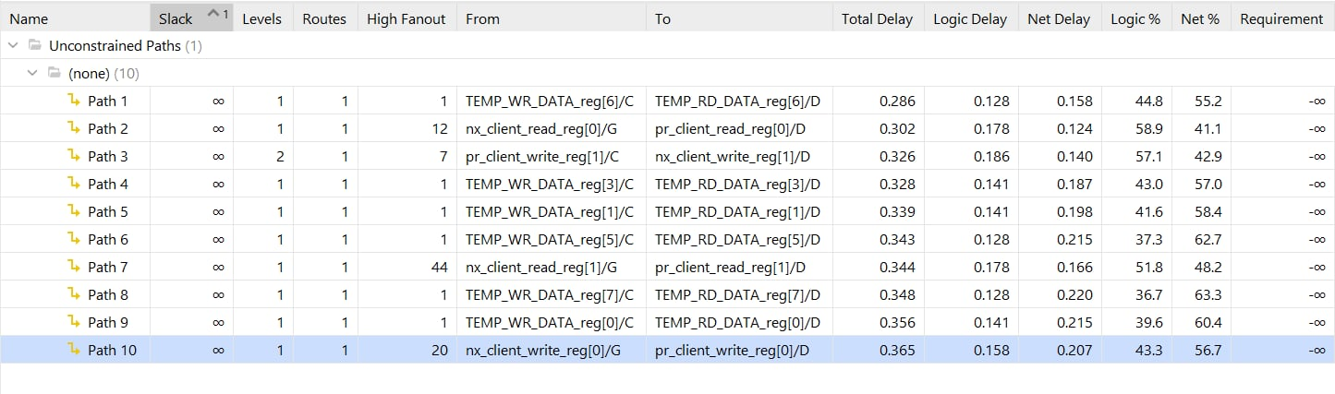

HOLD TIME

## 4. RAM ARBITER

### 4.1. PORT MAP IN BETWEEN RAM AND ARBITER

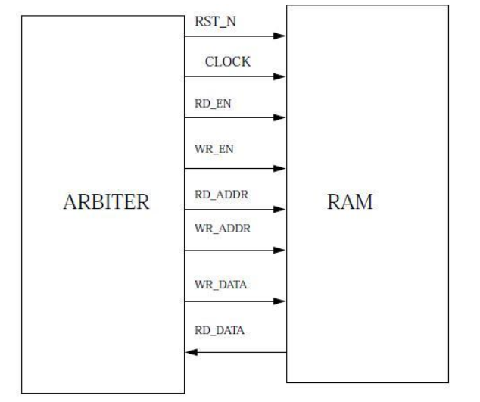

### 4.2. CODING

**module ram_arbiter #(**

**parameter G_ADDR_WIDTH = 4, // Number of bits required to address the RAM**

**parameter G_DATA_WIDTH = 8, // Number of bits in a data**

**parameter G_REGISTERED_DATA = 0 // 1 if output data is registered, 0 if not**

**)**

**(**

**input RST_N, CLOCK, // Reset and Clock signals**

**output RST_DONE, // Reset done signal**

**input RD_EN_C1, WR_EN_C1, // Read Enable and Write Enable signals from Client 1**

**input [G_ADDR_WIDTH-1 : 0] RDADDR_C1, WRADDR_C1, // Read and Write addresses from Client 1**

**input [G_DATA_WIDTH-1 : 0] WRDATA_C1,**  // Write data from Client 1

**input [G_DATA_WIDTH-1 : 0] DATAIN_C2,**  // Input data from Client 2

**input REQUEST_C2, RD_NOT_WRITE_C2,**  // Memory access request and read/write bar signal from Client 2

**input [G_ADDR_WIDTH-1 : 0] ADDR_C2,**  // Address for both read and write operations from Client 2

**output [G_DATA_WIDTH-1 : 0] RDDATA_C1,**  // Data out for Client 1

**output [G_DATA_WIDTH-1 : 0] DATAOUT_C2,**  // Data out for Client 2

**output ACK_C2**  // Acknowledgement signal for Client 2

**);**

// Wires to connect signals to the RAM module

**wire [G_DATA_WIDTH-1 : 0] WR_DATA, RD_DATA1;**

**wire [G_ADDR_WIDTH-1 : 0] WR_ADDR, RD_ADDR;**

**wire RD_EN, WR_EN;**

// Instantiate RAM module with parameters

**ram #(G_ADDR_WIDTH, G_DATA_WIDTH) dut1 (**

**.CLOCK(CLOCK),**

**.RST_N(RST_N),**

**.RD_EN(RD_EN),**

**.WR_EN(WR_EN),**

**.RD_ADDR(RD_ADDR),**

**.WR_ADDR(WR_ADDR),**

**.WR_DATA(WR_DATA),**

**.RD_DATA(RD_DATA1)**

**);**

// Instantiate Arbiter module with parameters

**arbiter #(G_ADDR_WIDTH,G_DATA_WIDTH,G_REGISTERED_DATA) dut2 (**

**.RST_N(RST_N),**

**.CLOCK(CLOCK),**

**.RST_DONE(RST_DONE),**

**.RD_EN_C1(RD_EN_C1),**

**.WR_EN_C1(WR_EN_C1),**

**.RDADDR_C1(RDADDR_C1),**

**.WRADDR_C1(WRADDR_C1),**

**.WRDATA_C1(WRDATA_C1),**

**.REQUEST_C2(REQUEST_C2),**

**.RD_NOT_WRITE_C2(RD_NOT_WRITE_C2),**

**.ADDR_C2(ADDR_C2),**

**.DATAIN_C2(DATAIN_C2),**

**.RD_EN(RD_EN),**

**.WR_EN(WR_EN),**

**.RD_ADDR(RD_ADDR),**

**.WR_ADDR(WR_ADDR),**

**.WR_DATA(WR_DATA),**

**.RD_DATA(RD_DATA1),**

**.DATAOUT_C2(DATAOUT_C2),**

**.ACK_C2(ACK_C2),**

**.RDDATA_C1(RDDATA_C1)**

**);**

**endmodule**

### 4.3. SCHEMATIC OF RAM ARBITER

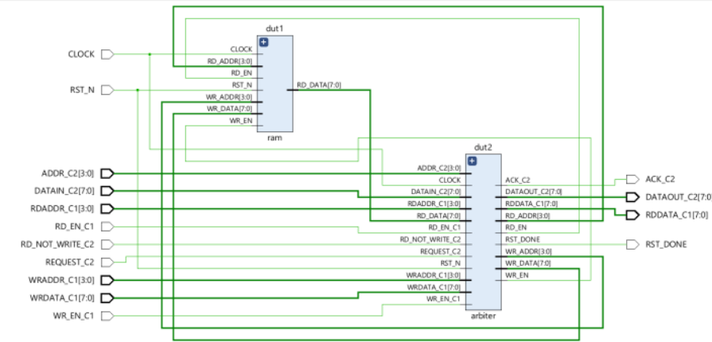

### 4.4. TESTCASES FOR RAM ARBITER

1. Client1 wants to read and Client2 wants to read in same RAM location at different time.
2. Client1 wants to read and Client2 wants to read in same RAM location at same time.
3. Client1 wants to read and write in the same RAM location and Client2 also wants to read in the RAM location where Client1 has written at different time.
4. Client1 wants to read and write in the same RAM location and Client2 also wants to read in the RAM location where Client1 has written at same time.
5. Client2 wants to read and write in the same RAM location and Client1 also wants to write in the RAM location where Client2 has written at same time.
6. Client2 wants to read and write in the same RAM location and Client1 also wants to read in the RAM location where Client2 has written at same time.

### 4.5. VERILOG TESTBENCH

#### 4.5.1. TESTBENCH CODE

**`timescale 1ns / 1ps**

**module RAM_ARBITER_TEST;**

**// Inputs**

**reg RST_N;**

**reg CLOCK;**

**reg RD_EN_C1;**

**reg WR_EN_C1;**

**reg [3:0] RDADDR_C1;**

**reg [3:0] WRADDR_C1;**

**reg [7:0] WRDATA_C1;**

**reg [7:0] DATAIN_C2;**

**reg REQUEST_C2;**

**reg RD_NOT_WRITE_C2;**

**reg [3:0] ADDR_C2;**

**// Outputs**

**wire RST_DONE;**

**wire [7:0] RDDATA_C1;**

**wire [7:0] DATAOUT_C2;**

**wire ACK_C2;**

**// Instantiate the Unit Under Test (UUT)**

**RAM_ARBITER_NEW uut (**

**.RST_N(RST_N),**

**.CLOCK(CLOCK),**

**.RST_DONE(RST_DONE),**

**.RD_EN_C1(RD_EN_C1),**

**.WR_EN_C1(WR_EN_C1),**

**.RDADDR_C1(RDADDR_C1),**

**.WRADDR_C1(WRADDR_C1),**

**.WRDATA_C1(WRDATA_C1),**

**.DATAIN_C2(DATAIN_C2),**

**.REQUEST_C2(REQUEST_C2),**

**.RD_NOT_WRITE_C2(RD_NOT_WRITE_C2),**

**.ADDR_C2(ADDR_C2),**

**.RDDATA_C1(RDDATA_C1),**

**.DATAOUT_C2(DATAOUT_C2),**

**.ACK_C2(ACK_C2)**

**);**

**// Clock process definitions**

**always begin**

**#25 CLOCK = ~CLOCK;**

**End**

**// Stimulus process**

**initial begin**

**// Test Case-1: Client1 wants to read and Client2 wants to read in same RAM location at**

**different time.**

**#100 RST_N = 1;**

**#200 WR_EN_C1 = 1;**

**#100 RD_EN_C1 = 0;**

**#200 WRADDR_C1 = 4'b1010;**

**#200 WRDATA_C1 = 8'b10101111;**

**#1700 RD_EN_C1 = 1;**

**#300 WR_EN_C1 = 0;**

**#200 RDADDR_C1 = 4'b1010;**

**// Test Case-2: Client1 wants to read and Client2 wants to read in same RAM location at same time.**

**#100 RST_N = 1;**

**#200 WR_EN_C1 = 1;**

**#100 RD_EN_C1 = 0;**

**#200 WRADDR_C1 = 4'b1010;**

**#200 WRDATA_C1 = 8'b10101111;**

**#1700 RD_EN_C1 = 1;**

**#200 WR_EN_C1 = 0;**

**#200 RDADDR_C1 = 4'b1010;**

**#100 REQUEST_C2 = 1;**

**#100 RD_NOT_WRITE_C2 = 1;**

**#200 ADDR_C2 = 4'b1010;**

**// Test Case-3: Client1 wants to read and write in the same RAM location and Client2 also**

**wants to read in the RAM location where Client1 has written at different time.**

**#100 RST_N = 1;**

**#200 WR_EN_C1 = 1;**

**#100 RD_EN_C1 = 0;**

**#200 WRADDR_C1 = 4'b1001;**

**#200 WRDATA_C1 = 8'b10101111;**

**#1700 RD_EN_C1 = 1;**

**#200 RDADDR_C1 = 4'b1001;**

**#200 WRADDR_C1 = 4'b1001;**

**#200 WRDATA_C1 = 8'b10100011;**

**#300 REQUEST_C2 = 1;**

**#100 RD_NOT_WRITE_C2 = 1;**

**#200 ADDR_C2 = 4'b1001;**

**#200 RD_EN_C1 = 0;**

**// Test Case-4: Client1 wants to read and write in the same RAM location and Client2 also**

**wants to read in the RAM location where Client1 has written at same time.**

**#100 RST_N = 1;**

**#200 WR_EN_C1 = 1;**

**#100 RD_EN_C1 = 0;**

**#200 WRADDR_C1 = 4'b1001;**

**#200 WRDATA_C1 = 8'b10101111;**

**#1700 RD_EN_C1 = 1;**

**#200 RDADDR_C1 = 4'b1001;**

**#200 WRADDR_C1 = 4'b1001;**

**#200 WRDATA_C1 = 8'b10100011;**

**#100 REQUEST_C2 = 1;**

**#100 RD_NOT_WRITE_C2 = 1;**

**#200 ADDR_C2 = 4'b1001;**

**#200 RDADDR_C1 = 4'b1001;**

**// Test Case-5: Client2 wants to read and write in the same RAM location and Client1 also**

**wants to write in the RAM location where Client2 has written at same time.**

**#100 RST_N = 1;**

**#200 WR_EN_C1 = 0;**

**#200 RD_EN_C1 = 0;**

**#100 REQUEST_C2 = 1;**

**#100 RD_NOT_WRITE_C2 = 0;**

**#200 ADDR_C2 = 4'b1001;**

**#200 DATAIN_C2 = 8'b11100011;**

**#1700 WR_EN_C1 = 1;**

**#200 RD_NOT_WRITE_C2 = 1;**

**#200 ADDR_C2 = 4'b1001;**

**#200 WRADDR_C1 = 4'b1001;**

**#200 WRDATA_C1 = 8'b10101111;**

**// Test Case-6: Client2 wants to read and write in the same RAM location and Client1 also**

**wants to read in RAM location where Client2 has written at same time.**

**#100 RST_N = 1;**

**#200 WR_EN_C1 = 0;**

**#200 RD_EN_C1 = 0;**

**#100 REQUEST_C2 = 1;**

**#100 RD_NOT_WRITE_C2 = 0;**

**#200 ADDR_C2 = 4'b1001;**

**#200 DATAIN_C2 = 8'b11100011;**

**#1700 RD_EN_C1 = 1;**

**#200 RD_NOT_WRITE_C2 = 1;**

**#200 ADDR_C2 = 4'b1001;**

**#200 RDADDR_C1 = 4'b1001;**

**end**

**endmodule**

**WAVEFORM**

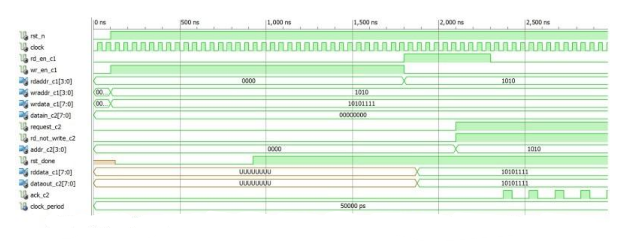

**Case 1: Client1 wants to read and Client2 wants to read in same RAM location at different time.**

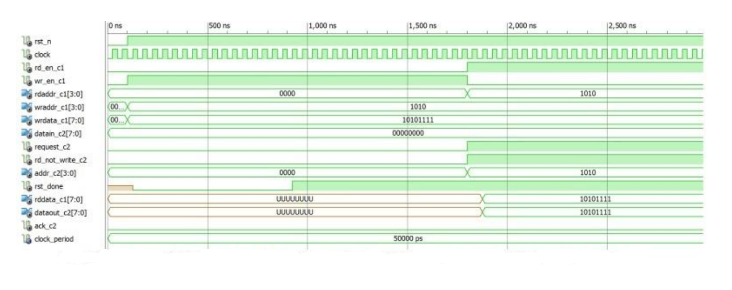

**Case 2: Client1 wants to read and Client2 wants to read in same RAM location at same time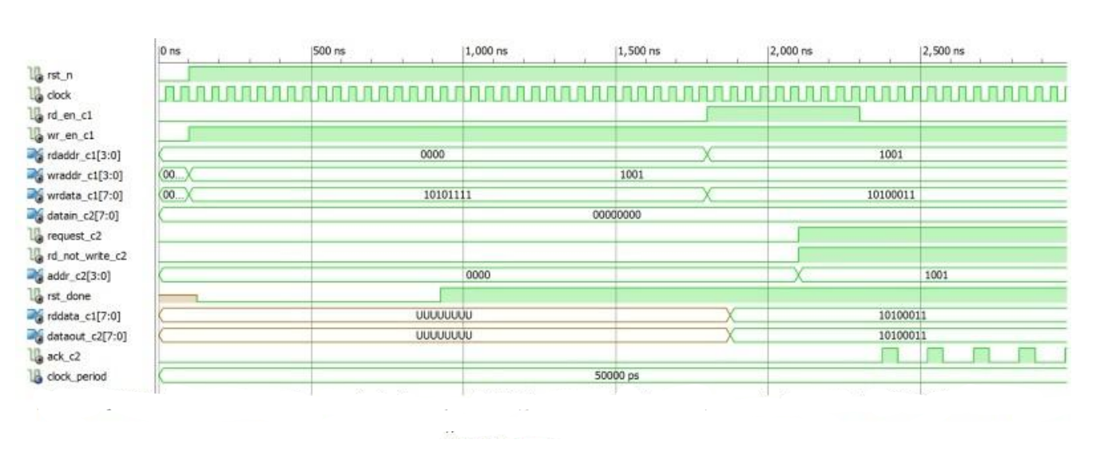Case 3: Client1 wants to read and write in the same RAM location and Client2 also wants to read in the RAM location where Client1 has written at different time.**

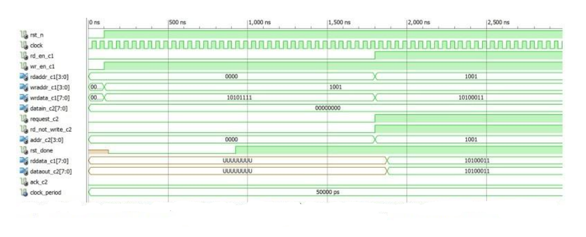

**Case 4: Client1 wants to read and write in the same RAM location and Client2 also wants to read in the RAM location where Client1 has written at same time.**

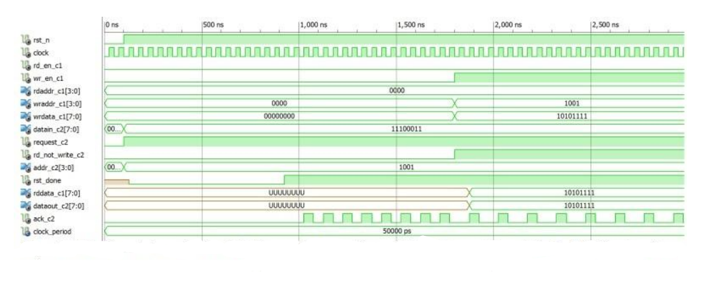

**Case 5: Client2 wants to read and write in the same RAM location and Client1 also wants to write in the RAM location where Client2 has written at same time.**

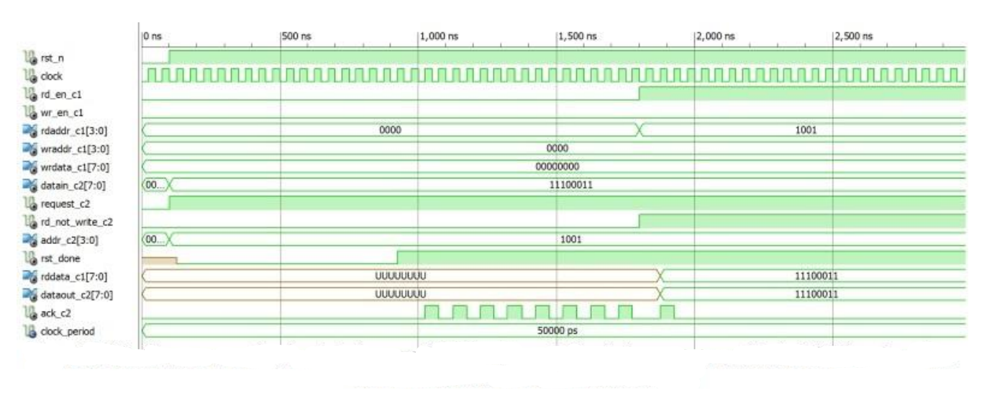

**Case 6: Client2 wants to read and write in the same RAM location and Client1 also wants to read in the RAM location where Client2 has written at same time.**

#### 4.5.2. ANALYSIS OF THE TEST CASES

**Case 1: Client1 wants to read and Client2 wants to read in same RAM location at different time.**

During the first RAM_DEPTH cycle, Client1 perform write operation at the address location “1010”. Subsequently in the next RAM_DEPTH cycle, both Client1 and Client2 try to access the RAM to read the same RAM address location. Since it a priority based arbitration system, Client1 gets access to the RAM compared to Client2. It is only when Client1 does not require the read operation any longer that the system grants access to Client2 which reads from the same location. There is a time delay of 500 ns after which Client1 sets its RD_EN_C1 to active low signal. Since both access the same RAM location at different time, this does not affect the clients on the whole.

**Case 2: Client1 wants to read and Client2 wants to read in same RAM location at same time**.

The present case is similar to the previous test case differing only in the fact that here the scheme of priority based arbitration is clearly visible. During the second RAM_DEPTH cycle, both the clients try to access the same RAM location at the same time but only Client1 gets access to the RAM. Since there is no output at ACK_C2 pin it bears testimony to our claims.

**Case 3: Client1 wants to read and write in the same RAM location and Client2 also wants to read in the RAM location where Client1 has written at different time.**

In this test case Client1 performs the write operation at the address location “1001”. In the second RAM_DEPTH cycle, Client1 as it enjoys the higher priority among the two, can simultaneously perform the read and write operation. It writes the data “10100011” at the previous address location However as previously also discussed, the output at the RDDATA_C1 pin is the apparent output which comes from the temporary register located in the Arbiter itself which provides this output when client1 performs the read operation. Since Client2 access the system at a different time (i.e. after 500 ns), the arbiter grants permission to Client2 to read from the same location as Client1 is not using the read operation. This can be observed by the setting low of the RD_EN_C1 signal near 2500 ns mark in the waveform graph.

**Case 4: Client1 wants to read and write in the same RAM location and Client2 also wants to read in the RAM location where Client1 has written at same time.**

Client1 performs the write operation at the address location “1001”. In the second RAM_DEPTH cycle, Client1 as it enjoys the higher priority among the two, can simultaneously perform the read and write operation. It writes the data “10100011” at the previous address location. However as previously also discussed, the output at the RDDATA_C1 pin is the apparent output which comes from the temporary register located in the Arbiter itself which provides this output when client1 performs the read operation. Since Client2 access the system at the same time, hence Client2 is unable to access the RAM at all.

**Case 5: Client2 wants to read and write in the same RAM location and Client1 also wants to write in the RAM location where Client2 has written at same time.**

During the first RAM_DEPTH cycle, Client2 performs the write operation at the address location “1001”. The data written is “11100011”. However in the second RAM_DEPTH cycle, since Client2 has a lower priority in the system, it can only read or write at any given time. The Arbiter only allows Client2 to read from the address location “1001”. This can verified from the pulses at the output pins of ACK_C2.Moreover, since Client2 reads, the arbiter at a later time allows Client1 to write to the RAM at the same address location. Almost instantaneously, the data given is sent to the input pins of the RAM and is also reflected at the output pins of DATAOUT_C2 and RDDATA_C1, the reason for which had already been discussed. We observe that the write operation of Client2 during the second RAM_DEPTH cycle is omitted.

**Case 6: Client2 wants to read and write in the same RAM location and Client1 also wants to read in the RAM location where Client2 has written at same time.**

In this case, Client2 performs a write operation during the first RAM_DEPTH cycle. In the next cycle, one would observe that around 1700-1800 ns that Client2 performs the read operation on the address location “1010”.This is more clear from the type of the output pulses at the output pin of ACK_C2. But almost within 25-50 ns, we see that the Arbiter grants the read operation to Client1 who enjoys a higher priority. The ACK_C2 signals stops giving any output. Since both Client1 and Client2 try to perform the read operation at the same time, it may be somewhat difficult to comprehend the change with the naked eye.

### 4.6. POWER & TIMING

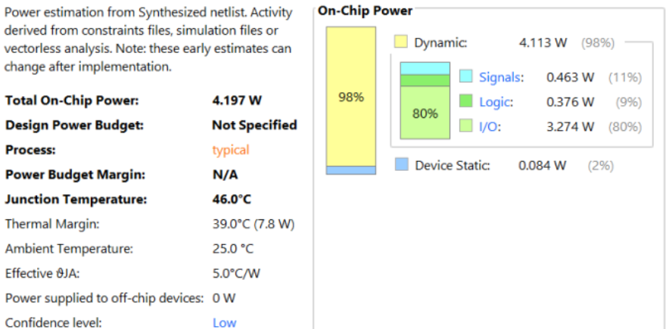

**POWER**

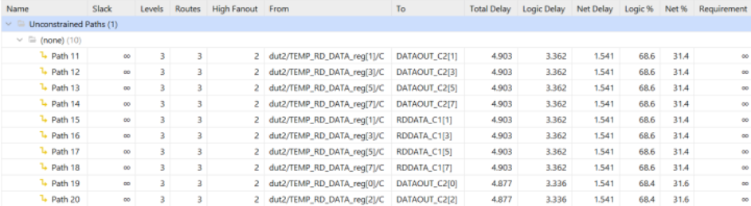

**SET UP TIME**

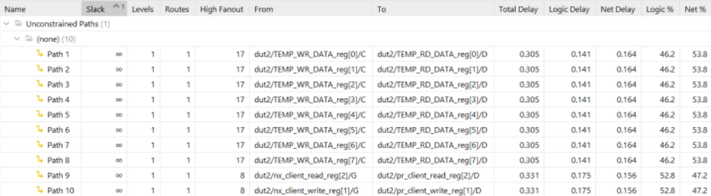

**HOLD TIME**

# **PART C: CONCLUSION**

**General Comments on the Results:**

The project has achieved success in designing and implementing an Arbiter for RAM, utilizing a priority system to manage access from various data sources. The primary function of the Arbiter is to allocate access privileges to RAM between Client 1 and Client 2, ensuring effective and equitable resource utilization.

**Limitations and Challenges:**

While there has been simulation and testing of some cases, the testbench's scope is still limited, unable to guarantee the Arbiter's completeness and comprehensiveness in all scenarios. There is a need to enhance the implementation of the testbench for the remaining blocks to verify and ensure the correctness of the entire system.

Development Suggestions:

* Expand the testbench to thoroughly assess the entire system under diverse conditions and different scenarios, particularly in boundary cases and error situations.
* Implement intricate test cases to ensure the Arbiter operates correctly and reliably in diverse environments.
* Integrate automatic testing mechanisms and performance evaluations to ensure the Arbiter meets speed and workload processing requirements.

These development suggestions aim to enhance the quality and reliability of the Arbiter, ensuring its stability and correctness in various usage conditions.

# **PART D: REFERENCES**

1. Architectural Design of a RAM Arbiter_Sourangsu Banerji_Department of Electronics & Communication Engineering, RCC-Institute of Information Technology, Under West Bengal University of Technology, April, 2014
2. M. Weber, "Arbiters: Design Ideas and Coding Styles," Synopsys Users Group, Boston, 2001.
3. E. S. Shin, V. J. Mooney III, G. F. Riley, “Round-robin Arbiter Design and Generation,” Georgia Institute of Technology, Atlanta, GA, Technical Report GIT-CC-02-38,2002.
4. https://github.com/faizaan22/Arbiter-for-RAM-module/blob/main/Arbiter%20report.pdf
5. L. Fischer and Y. Pyatnychko, "FPGA Design for DDR3 Memory," WPI, Worcester, 2012.
6. Principles and practices of interconnection networks, William James Dally and Brian Towels, Morgan Kauffmann.